**Loan Eco Setup on Docker Local Machine**

**Prerequisite:**

1. Install Docker for windows and set environment variables to use with Power Shell.
2. Install Git and set environment variable to use with Power Shell.
3. Install vim for Power Shell

**Step 1.** Open Power Shell and check docker, docker-compose, git and vim version.

*docker -v*

*docker-compose -v*

*git --version*

*vim -v*

**Step 2.** Clone the source code to desired directory and go to the directory

*git clone https://github.com/ensarloaneco/mmkt.git*

**Step 4.** Build the containers

*docker-compose build*

*docker images*

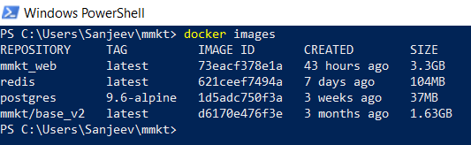

**Step 5.** Run the containers

*docker-compose up*

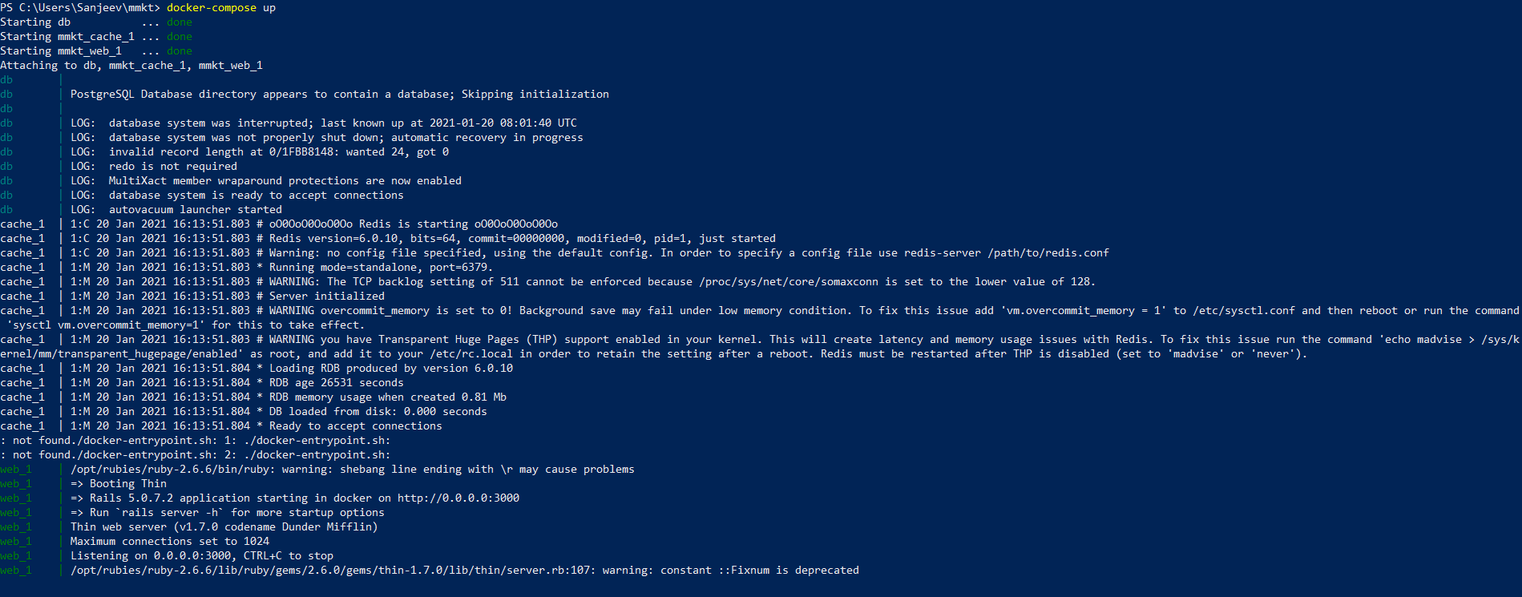

**Step 6.** Run the command to restore the database. Enter database password ‘docker’.

*docker-compose exec web /bin/sh -c "bundle exec rake db:restore"*

*docker-compose exec web /bin/sh -c "bundle exec rake db:migrate"*

**Step 7.** Check the running container status

*docker ps -a*



**Step 8.** Enter the postgres container bash to check the database and role

*docker exec -it <container id> bash*

*bash-5.0# psql -U docker*

*docker=# \l*

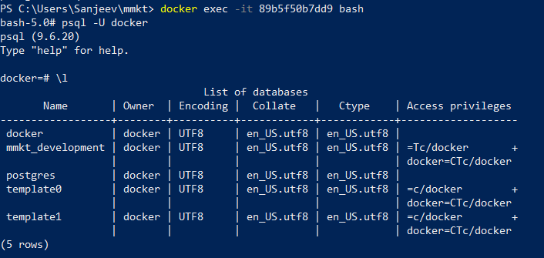

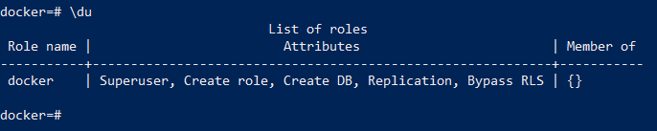

**Step 9.** Select the database mmkt_development and check the table schema

*\c mmkt_development*

*\dt+*

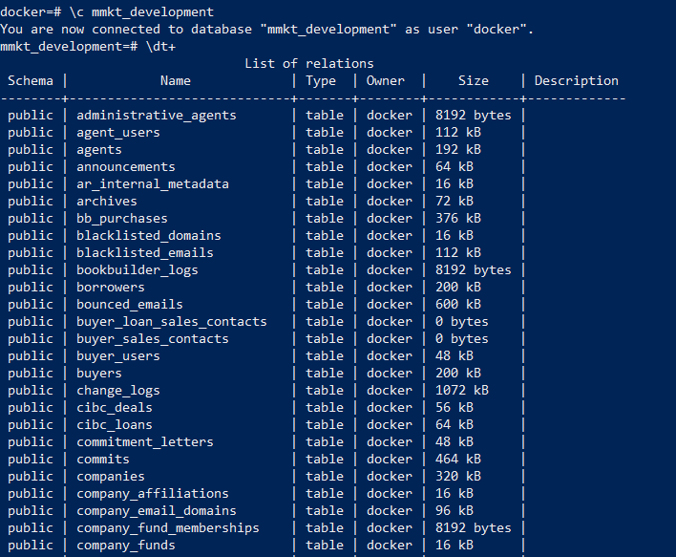

**Step 10.** Check the application in web browser running on <http://localhost:3000>

